Ethan Allen Corner Cupboard

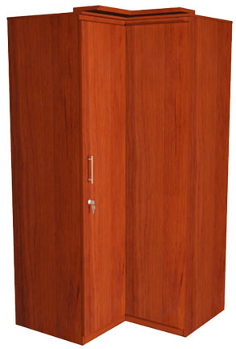

|  |
| --- |
| **DESCRIPTION** |
| Ethan Allen interior designing has introduced corner applied room cupboard  (V cupboard) with two functional doors. The cupboard has a nice feel with smooth surface and the metallic wooden feeling used to maintain temperature. It will give your house a complete different look and a door with multi space stores long and wide valuables that easily fits into the cupboard. The cupboard is designed to fit and to be place in any corner of the room. |

|  |  |  |
| --- | --- | --- |
| **Price** | **995$** | |
| **Dimensions** | **(First Portion) H** x **W** x **L** | **77in x 20in x 28in** |
| **(Second Portion) H** x **W** x **L** | **77in x 20in x 28in** |
| **Features** | **Indorse wood helps to keep a natural look and 90 degree shape enables the cupboard to attach towards the corner of the room.** | |
| **Finished** | **Wooden Shine Polish** | |
| **Available in** | **Brown and Black** | |